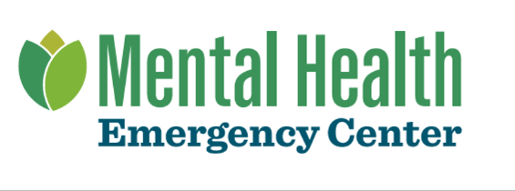

Mental Health Emergency Center Financial Assistance Attachment A

Participating Provider List
Current as of October 1, 2022

Any and all providers rendering services at Mental Health Emergency Center are Participating Providers and will provide Financial Assistance for Eligible Services provided to Eligible Patients, as those terms are defined in Mental Health Emergency Center’s Financial Assistance Policy.

There are no providers rendering services at Mental Health Emergency Center that are non-Participating Providers.

For more information about Participating Providers or Mental Health Emergency Center’s financial assistance policy, please contact us at:

Visit: https://mentalhealthmke.org/financial-assistance/
Call: 414-441-9670 to speak to a financial advocate
Mail a request: Financial Assistance, PO Box 0909996, Milwaukee, WI 53209-0996

